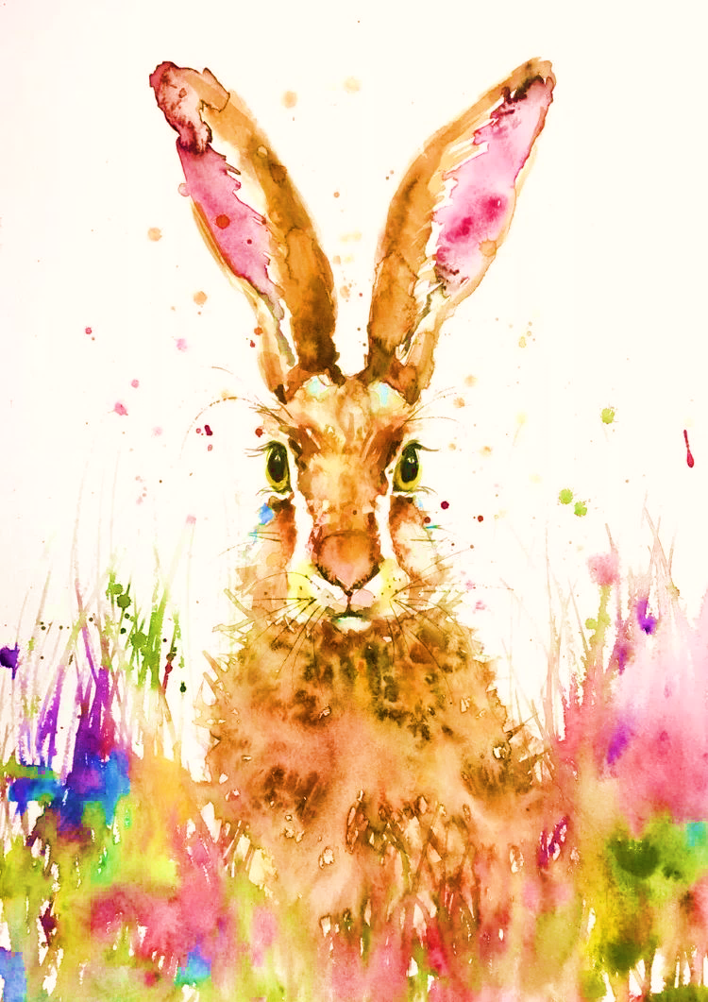**RABBIT *after dinner***

(All cocktails £12)

|  |
| --- |
| **WOOKEY HOLE CHEDDAR, RACHEL’S GOAT, CASHEL BLUE, BATH SOFT 15.0**  **BREAD PUDDING, SOFT CREAM CHEESE, STRAWBERRY COMPOTE 12.0**  **CITRUS CHEESECAKE, RASPBERRIES 8.0** |

***SPARKLING***

**Seasonal** **bellini** – Strawberry puree, Rich Vanilla, Nutty Wild

**Limoncello** **Spritz**- Limoncello, Beeson, Orange bitters, Nutty Vintage

***SWEET***

**Fizzy Bramble**- Raspberries, Strawberries, Lemon, Vodka, Watermelon Soda

**Bloody Margarita**- Tequila, Lime, Gomme, Domaine De Pellehaut

***Sour***

**Amber** **Rhubarb**- Amber Vermouth, Rhubarb gin, Gomme, Lime, Apple

**Metropolitan**- Blood orange gin, Cointreau, Lemon, Cranberry, Vanilla

HERBAL

**Emerald dragon-** Dry gin, Kummel, Crème de Menthe, Lemon

DESSERT

**Sussex** **Coffee-** Single malt Whiskey, Espresso, Vanilla and Toffee Cream

**Black** **Forest-** Fruit Punch gin, Lingonberry, Crème de Cassis, Cream, Cointreau

**Fudge-** Cream and Coffee Liqueur, Cinnamon, Honey, Toffee, Cream

CHEMISTS SECRET

**Lobe Blaster-** Dry gin, Butterfly gin, Coffee liqueur, Lemon, Rich Vanilla syrup

Please note that a discretionary service charge of 13.5% will be added to your bill.

Kindly inform us of any allergens when ordering your meal.